Name--_________________________ Date--__________________
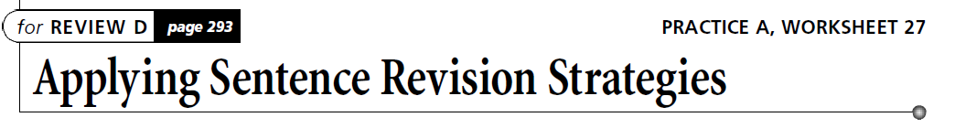

DI R E C T I O N S Use the skills you have learned throughout this chapter.
- Revise the following paragraph to revise fragments, run-ons, and stringy and wordy sentences.
- Try to combine at least five sentences when you revise.

Leonardo da Vinci was born in 1452. His birth took place in Italy. Died
in 1519. Leonardo was a skilled scientist, he was also a talented artist. One
of his masterpieces is The Last Supper. He painted it on dry plaster, which
is a poor surface for oil paints. The painting soon began to disintegrate. Its
disintegration was gradual. Leonardo also painted the Mona Lisa. This is his
most famous and well-known work. He must have liked this painting.
Because he carried it with him when he traveled. Leonardo’s scientific contributions are impressive as well, he was ahead of his scientific peers. He filled
many notebooks with scientific theories and observations and he wrote
his notes in mirror script. He used this writing and it was difficult for other
people to read them. He planned many devices, such as an underwater diving
suit. That were not actually created for hundreds of years. People still re cognize
the name of Leonardo da Vinci. They recognize it centuries after his lifetime.

